**Section 1: Multiple Choice**

|  |  |  |
| --- | --- | --- |
| **Assignment** | **:** |  |
| **Module -1: Understanding of Hardware and Its**  **Components** | | |

1. **Which of the following is NOT a component of the CPU?**
   1. ALU
   2. RAM
   3. CU
   4. 1 and 3 both

Ans. RAM

Note. RAM is a Primary storage and it is not Component of CPU.

1. **What is the function of RAM in a computer?**

Ans. Ram Stands for Random Access Memory and it is used for store the data and process for it quickly.

1. **Which of the following is a primary storage device?**
   1. HDD
   2. SSD
   3. SD card
   4. 1 and 2 both

Ans. 1 and 2 both

Note. In HDD and SSD Storage we have a Primary Storage Partition. So they are also known as Primary Storage

1. **What is the purpose of a GPU?**

Ans. GPU stand for Graphic Processing Unit and it is use to improve its graphic effect and its graphic level.

**Section 2: True or False**

1. **True or False: The motherboard is the main circuit board of a computer where other components are attached.**

Ans. True.

1. **True or False: A UPS (Uninterruptible Power Supply) is a hardware device that provides emergency power to a load when the input power source fails.**

Ans. True.

1. **True or False: An expansion card is a circuit board that enhances the functionality of a component**.

Ans. True.

**Section 3: Short Answer**

1. **Explain the difference between HDD and SSD.**

Ans.

|  |  |
| --- | --- |
| **Solid-State Drive (SSD)** | **Hard Disk Drive (HDD)** |
| Random access time 0.1ms. | Random access time 5-10ms. |
| Read latency time very low. | Read latency time high. |
| 100MB/s to 500MB/s | 50MB/s to 100MB/s |
| High Reliability | Low Reliability |
| SSD doesn’t have moving part to fail | HDD have moving parts and subjects to sudden failures |
| Small and light in weight | Relatively large and heavy in weight |
| Till now SSD are available in size of 30TB | Till now HDD are available up to 32TB |
| Power Consumption is 2watts | Power Consumption is 6-12watts |

1. **Describe the function of BIOS in a computer system.**

Ans. BIOS stand For Basic Input Output System in which we can do setup inside the bios. In BIOS we can do functions like Booting the Windows and Pen drive, also we can change the settings of the systems from inside the BIOS.

1. **List and briefly explain three input devices commonly used with computers.**

Ans. There are many types of input devices but here we have the main three input devices.

1. Keyboard
2. Mouse
3. Webcam

Here are the brief explanations of these three devices.

1. Keyboard: Keyboard is an input device. we can use it to input the text and write the commands inside the system. It is also known as main input device.
2. Mouse: Mouse is an input device. With the use of mouse, we can go where we want to point, we can also open and close the application that we have inside the system. And it is also known as pointing device.
3. Webcam: Webcam is an input device. We can use it to input the Images and the videos as an file mode.

**Section 4: Practical Application**

1. **Identify and label the following components on a diagram of a motherboard:**

* CPU
* RAM slots
* SATA connectors
* PCI-E slot

Ans.

* CPU: It is a main part of motherboard. It is also known as mind of the motherboard, CPU housed in the square type socket it is also known as CPU Socket.
* RAM Slot: RAM Slot is mainly near by the CPU and it has signal slot for a RAM, there are more than one slot in motherboard for RAM. It is also Suggest as Memory Slots in the motherboard.
* SATA Connectors: It is a connector of HDD and SSD with motherboard. It has small rectangular box with a line with cut inside it where we can connect the SATA Connector.
* PCI-E Slot: It is a part of motherboard. Which we can see near the GPU Slot, the PCI-E slot is use to allow the users to add the expansion cards in the computer.

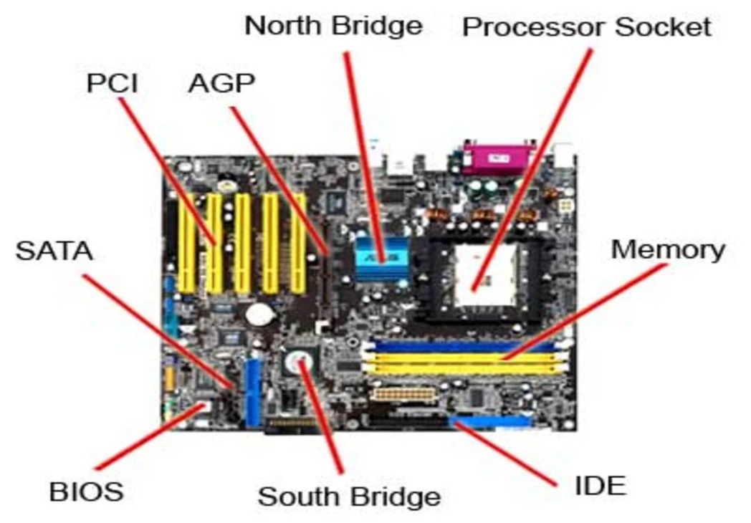

1. **Demonstrate how to install a RAM module into a computer.**

Ans. To install RAM into the RAM Slot we have to follow some steps like...,

1. We have to search slot for RAM in motherboard.
2. Then we have to open the lock of that RAM slot.
3. Then we have to see the cut in the RAM and match it within the Ram Slot, and then put the RAM inside that RAM slot and push it inside properly.
4. And at the end it will fix inside the slot properly it will automatically lock the RAM inside the slot.
5. And it’s Done.

**Section 5: Essay**

1. **Discuss the importance of proper cooling mechanisms in a computer system. Include examples of cooling methods and their effectiveness.**

Ans. In the computer system mechanisms are important to maintaining proper cooling for performance, reliability, and longevity of computer systems. Heat generated by components like the CPU, GPU, and power supply can lead to overheating.

**1. Air Cooling:** In these air-cooling methods there are two types 1) Fans and 2) Heatsinks. In which fans are the most common method to using air flow to dissipate heat. Heatsinks is a type of blocks that absorb the heat from the components.

**2.** **Liquid Cooling**: It provides the high- performance and good cooling system in the favored of working process of motherboard.

**3. Thermoelectric Cooling:** It is a cooling component effectively and it also require some cooling methods to manage heat.

1. **Explain the concept of bus width and its significance in computer architecture.**

Ans. In the computer bus width are refers the number of bits that can be transmitted in computer system. In the computer architecture, data transfer rates and all system performance.

1. Data Transfer Capacity: It can transfer the or carry more data at a time. It can increase the amount of the data to process and improve the performance of the system.
2. Performance: In performance we can increase the speed of the performance of the System like CPU and the memory transfer speed.
3. Memory Addressing: In this we can transfer the large memory data that we have to addressed. In which system require the large amount of Data Storage like RAM and HDD, SDD.
4. Compatibility: In this we can add the different components at the limiting performance like CPU to Pen drive.